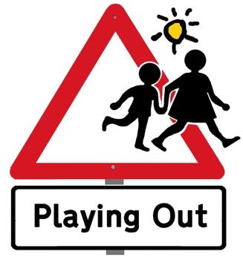
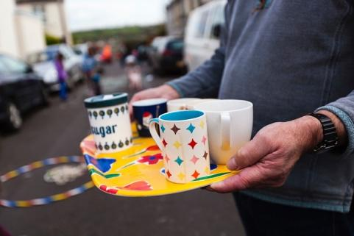

Dear Neighbours,

We hope that you all had the opportunity to enjoy one of our street gatherings last year. We have really been delighted with the response. As well as the children really loving playing on the closed road, the adults have very much enjoyed getting to know each other over a cup of tea.

We are keen to carry on this year and would like to apply again to St Albans District Council’s Playing Out scheme for permission to close the road to through traffic for a few hours on some occasions. We could also use the space for other activities such as book, toy or plant swaps.

This is a quick note to ask for your views on this. If you have any thoughts on dates, would like to raise any concerns, or would like to help, please do get in touch in the next two weeks.

Volunteers to act as stewards in high viz jackets are absolutely essential for the sessions to go ahead. Please let us know if you would be able to help with this - or with manning the tea station, leaflet delivery or any other help with organising the sessions.

Best wishes,

Name 1: house number, email, phone
Name 2: house number, email, phone

Further information on St Albans District’s “Playing Out” scheme.

Playing Out or Play Streets schemes involve closing a residential street for a few hours up to 8 times a year so children can play and adults can socialise.
Road closures are stewarded in order that resident cars can still have access and cars can still be parked in the closed area of the street. Children remain the responsibility of their parents. Everyone in the street is welcome.
Please see: https://sustainablestalbans.org/playing-out/ for more info.

